2025 VILLAGE OF THE HILLS BULK PICK UP SCHEDULE

BULKY WASTE COLLECTION

- Bulk Waste Collections will occur on a quarterly basis.

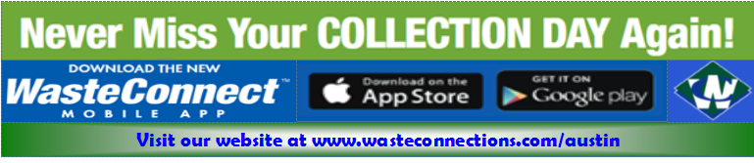

- and must be bundled or tied with string or twine.
Unacceptable Items:

BULKY WASTE COLLECTION

- Bulk Waste Collections will occur on a quarterly basis.

- The Quarterly Curbside Bulk event is pre-scheduled event dates are provided on the collection calendar
- All Items must be placed at the curb by 6am.
- Each residence is allowed Up to four (4) cubic yards of acceptable items.

- Individual items must not exceed fifty (50) pounds, so as to allow for manual loading by a two-person team.

- Appliances such as refrigerators, freezers, and air conditioners MUST be tagged to certify Freon has been properly removed

- Yard trimmings must be bagged or bundled for collection. Limbs that cannot be bagged must not exceed 4-foot length and 8 inch diameter and must be bundled or tied with string or twine.

Unacceptable Items:
NO Hazardous Material
NO Liquids, Solvents, Freon, or any items containing Freon
NO Chemicals, herbicides, pesticides
NO Asbestos
NO Propane Tanks
NO Batteries
NO Radioactive Material
NO Biohazard or Medical Waste (Red Bags)
NO Incinerator Ash
NO Contaminated Soil
NO items with PBC’s (microwaves, televisions, computer monitors, etc.)
NO Florescent Bulbs
NO Hazardous Material
NO Liquids, Solvents, Freon, or any items containing Freon
NO Chemicals, herbicides, pesticides
NO Asbestos
NO Biohazard or Medical Waste (Red Bags)
NO Incinerator Ash
NO Contaminated Soil

Trash & Recycle Service
Holiday Observed Service will be one day later

Bulk Pick Up

